Lab 10: Anti Reversing Techniques

CYBR 688: Software Reverse Engineering

Team Members: Sairam Bokka, Ethan Hart

Introduction:
The goal of this lab is to learn about and apply anti-reversing methods to a program that executes a sensitive key-checking algorithm. This lab will cover a brief analysis of the algorithm used in the program and the implementation of two anti-reversing techniques applied to the program to protect the sensitivity of the algorithm. One technique will aid in preventing static analysis, while another technique will attempt to prevent dynamic analysis.

Materials:
-Licensed copy of Linux (Ubuntu 24.04.1 Virtual Machine used for this lab).
-Supplied lab files from Blackboard, which includes the license key checker.

Procedure

Key-Checking Algorithm Overview
- Program Flow:
- The program takes two command-line arguments: username and key
- The key must be 32 characters long, representing 16 bytes in hexadecimal format
- The program processes the username through a SHA1 hash and performs a comparison with the key
- Key Validation Process:
- The doCheckConvert function:
  - Verifies the key is exactly 32 characters long
  - Converts the hex string key into 16 bytes
  - Passes these to doCheck
- Core Algorithm (doCheck):
- Takes the username and generates its SHA1 hash using OpenSSL
- Performs two calculations:
  - checkSHA1: Takes the SHA1 hash bytes and reduces them to a 16-bit value by:
    - Multiplying by 31 and adding each byte of the SHA1 hash
  - checkKey: Takes the provided key bytes and reduces them to a 16-bit value by:
    - Multiplying by 127 and adding each byte of the key
  - The key is valid if these two 16-bit values match
- Debug Mode Features:
- In debug builds (_DEBUG), there's a key generator that:
  - Takes just a username as input
  - Generates random keys and tests them
  - Continues until it finds a working key
  - Uses a simple increment strategy to try different keys

Static Analysis Prevention
- STRIP command (strip simplecrackme.cpp):
- The strip command removes debugging symbols, comments, and other metadata from executable files and object files.
- It removes:
- Debug information used for debugging/development
- Symbol table information (function and variable names)
- Line number information
- Source file names/paths
- Comments and non-essential metadata
- It reduces the file size and makes reverse engineering more difficult since symbol names and debug info are gone
- It does not affect the program's functionality

- Control Flow Flattening with State Machine Implementation
This technique transforms sequential code into a state machine, making it harder to understand the program's logic flow. In our implementation, we transformed the main checking logic into a state machine:
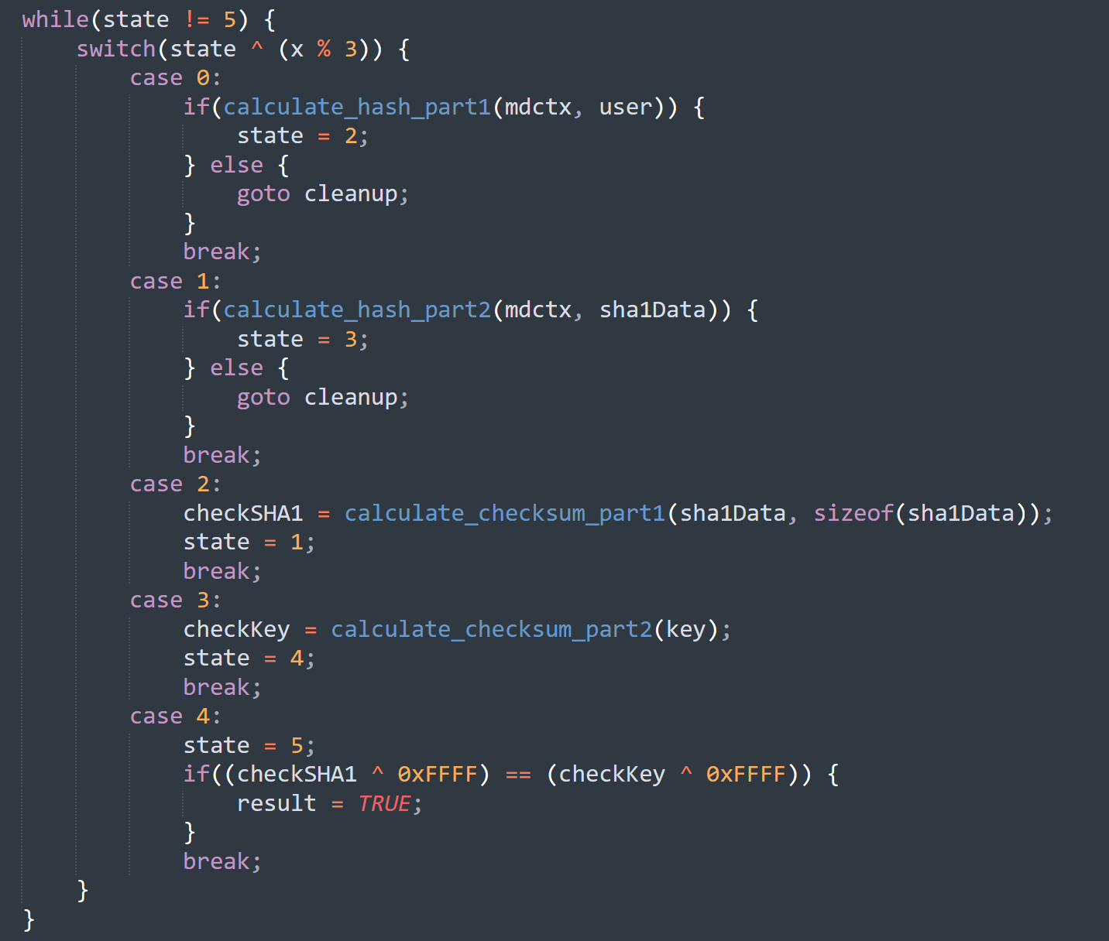
The state transitions are deliberately non-sequential (0 → 2 → 1 → 3) and further obscured by the XOR operation with a varying value. This makes it difficult to understand the actual execution order.

- Opaque Predicates with Mathematical Complexity
We implemented opaque predicates using mathematical properties that are hard for static analyzers to evaluate but have predetermined outcomes:
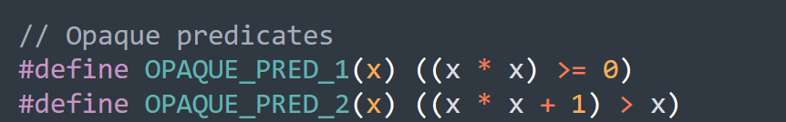
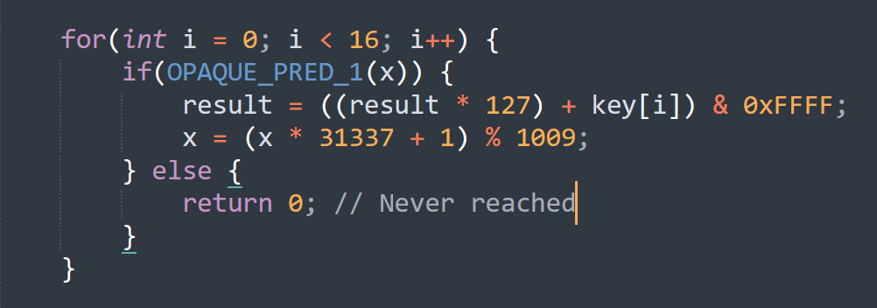
These predicates are used strategically throughout the code to create apparent decision points that have fixed outcomes.

- Function Splitting with Data Flow Obfuscation
We split core functionality into multiple functions and added data flow obfuscation within each part:
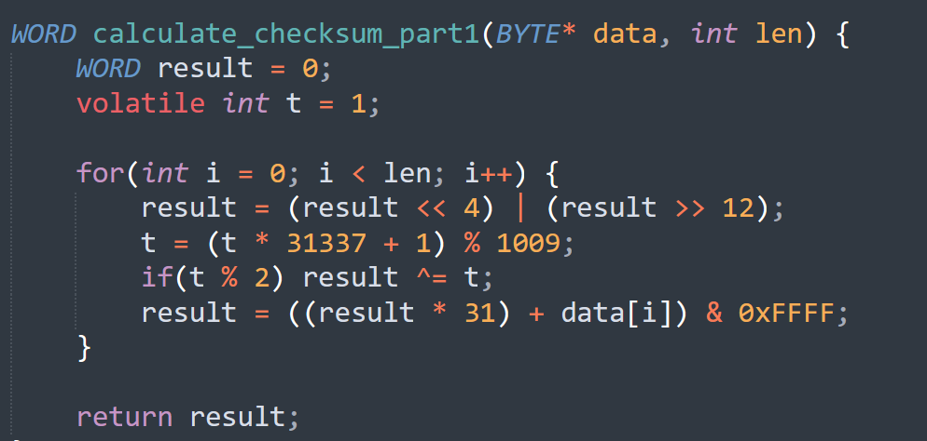

- Anti-Optimization Techniques with Volatile Variables
We used volatile variables to prevent compiler optimization of our obfuscation techniques:
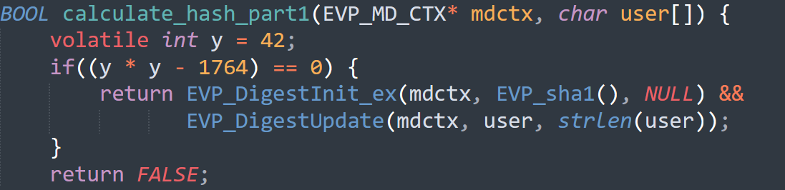

Dynamic Analysis Prevention
- Debugger Detection Using ptrace:
- To successfully obfuscate our code against dynamic analysis, we must embed an anti-debugger mechanism within our program.The mechanism implemented in this lab revolves around the ptrace() system call in Linux.
- The ptrace() system call is leveraged by debuggers such as gdb and strace, allowing one process (the tracer) to take control of another (the tracee).
- One feature of ptrace() on Linux is that a tracee can only be controlled by a single tracer at a time. If another program attempts to be the tracer of that same tracee, that program’s control request will be blocked.
- If gdb is launched with our executable, the executable becomes the tracee of a ptrace() system call executed by gdb.
- In our executable, we can make a call to ptrace() with the requested tracee process being the executable itself.
- When it returns with a failure code, the executable crashes and returns an ambiguous error message to point the user toward fixing the program’s input parameters.

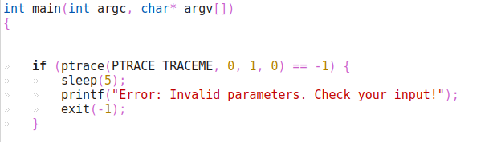
Executable source code calls ptrace() on itself to see if a debugger is attached.
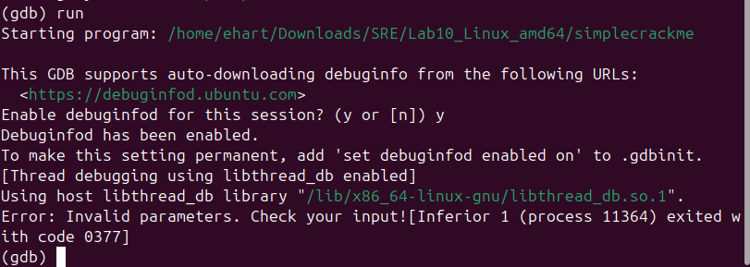
An unsuccessful attempt to debug the executable through gdb on Linux.
- Timing Integrity Checks:
- This technique exploits the significant time difference between normal execution and debugged execution.
- When a program is being debugged or analyzed, operations take much longer due to single-stepping or breakpoints. We implement a precise timing mechanism using gettimeofday():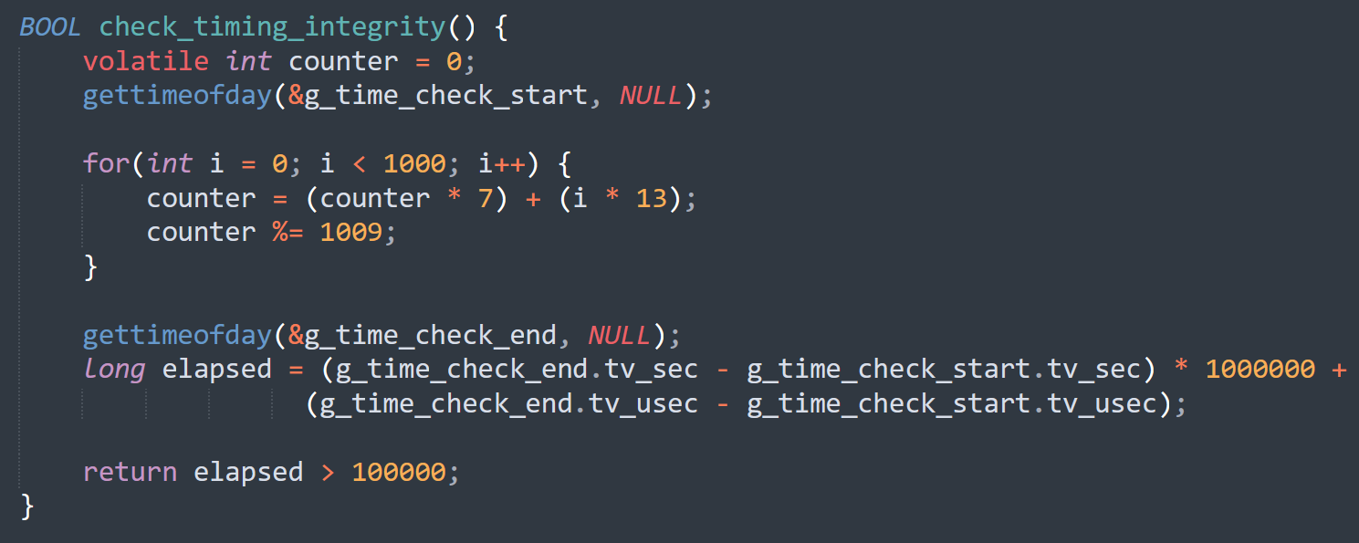
- The loop performs calculations that should complete very quickly under normal execution but will take significantly longer if being single-stepped or if breakpoints are hit. The volatile keyword prevents compiler optimization that might affect our timing measurements.

- Signal Handler Protection:
- We implement signal handlers to detect debugging attempts and protect against common debugging techniques:
- 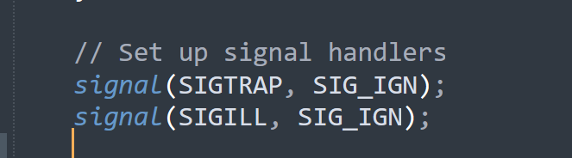
- SIGTRAP is typically used by debuggers to implement breakpoints. By ignoring it, we make it harder for debuggers to function properly. SIGILL helps prevent certain types of code manipulation, and SIGALRM provides our timing protection mechanism.

- Code Integrity Verification:
This protection calculates a runtime checksum of our code segment to detect modifications. The implementation uses a rolling hash algorithm that's sensitive to any code changes: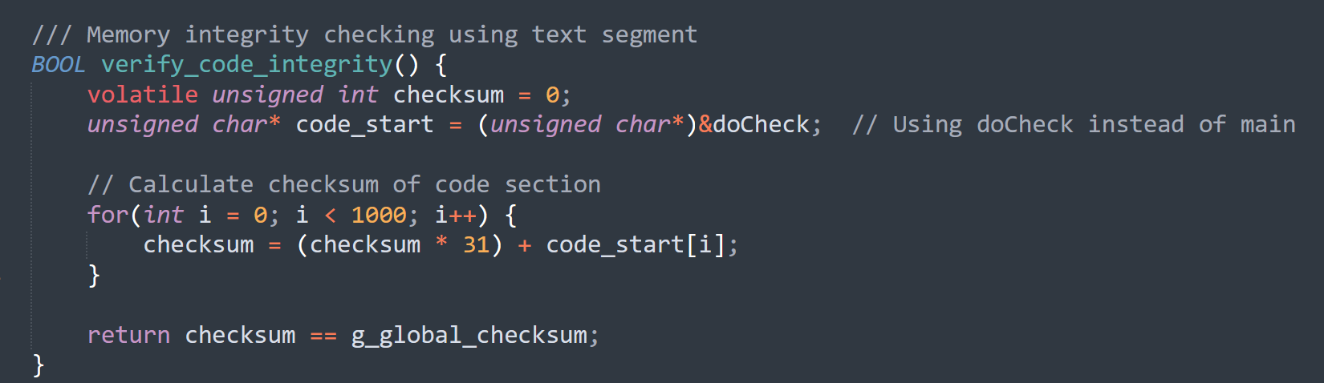

Conclusion

